Alexander Lizzo

Internetworking 307

Professor John Ringel

*Internetworking Class 1 -* Jan 23th 2020

IPV4

OSI Model:

7.Application Layer

6. Presentation Layer

5. Session Layer -

4. Transport Layer – Transmission Control Protocol /User Diagram Protocol (UDP)

3. Network Layer

2. Data Link

1. Physical Link

TCP/IP Model:

5. Application level (which covers 7,6,5 in the OSI model)

4. Transport

3. Network – IP address

2. Data layer

1. Physical level

Network mapping:

Square with an “x” in the center is a switch

Circle with an “x” in the middle is a router

Straight line - Through line

Dotted line -- Cross over cable

Squiggly line – WAN cable

Shielded Twisted Pair (STP)

Unshielded Twisted Pair (UTP)

Through cable – one device to another kind

Crossover cable – to like devices.

Optics:

Multi mode

Single mode

Computer hubs – antiquated machine that can generate loops. The hub receives a packet and send the packet out of every port in the machine.

WAN – wide area network

PAN – personal area networks

MAN – metropolitan area network. (city wide - one provider)

LAN – local area network

Port on desk

1 connects to router

2 connects to switch

3 LAN connection

4 empty

5 empty

6 internet connections

TCP/IP Networking Model

Adjacent Layer interactions – refers to the concepts of how adjacent layers in Networking model on the same computer, work together. Ie the higher-level Http wants error recover so it uses the lower level protocol (transport TCP layer).

Same-layer interaction – when a particular layer on the computer want to communicate with the same layer on another computer, the two computers use headers to hold the information they want to communicate.

TCP/IP Model:

5. Application level

HTTP header on packet frame that fetches request from server

4. Transport

TCCP Error recovery Basics

- TCP message is called a segment has a sequence number, when one of those segments fails to deliver then the client computer will request that segment again.

3. Network – IP protocol

2. Data layer -header and tail!

1. Physical level

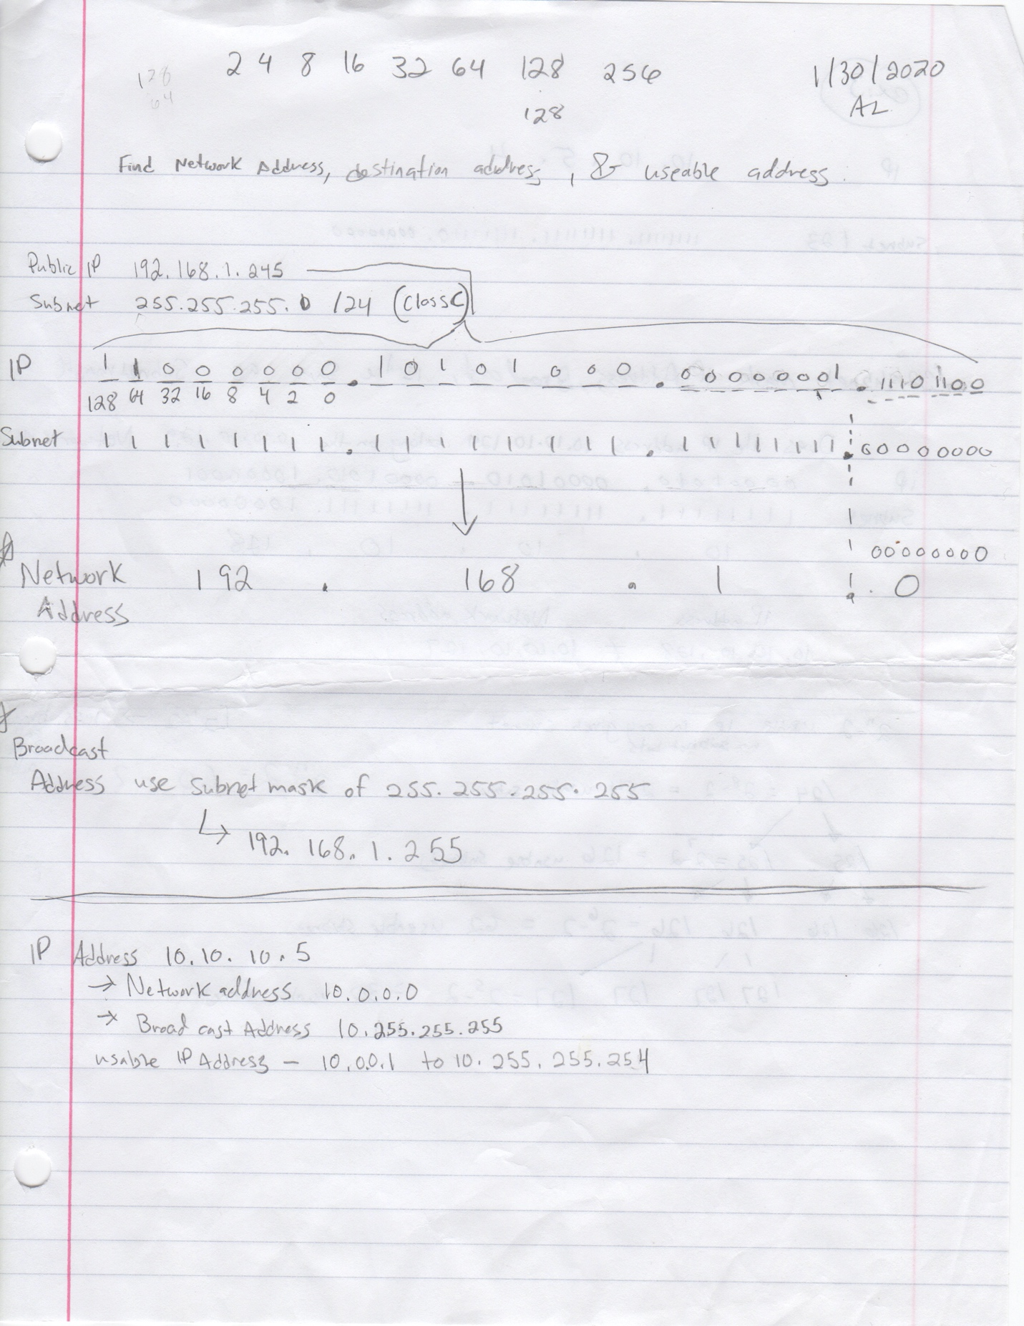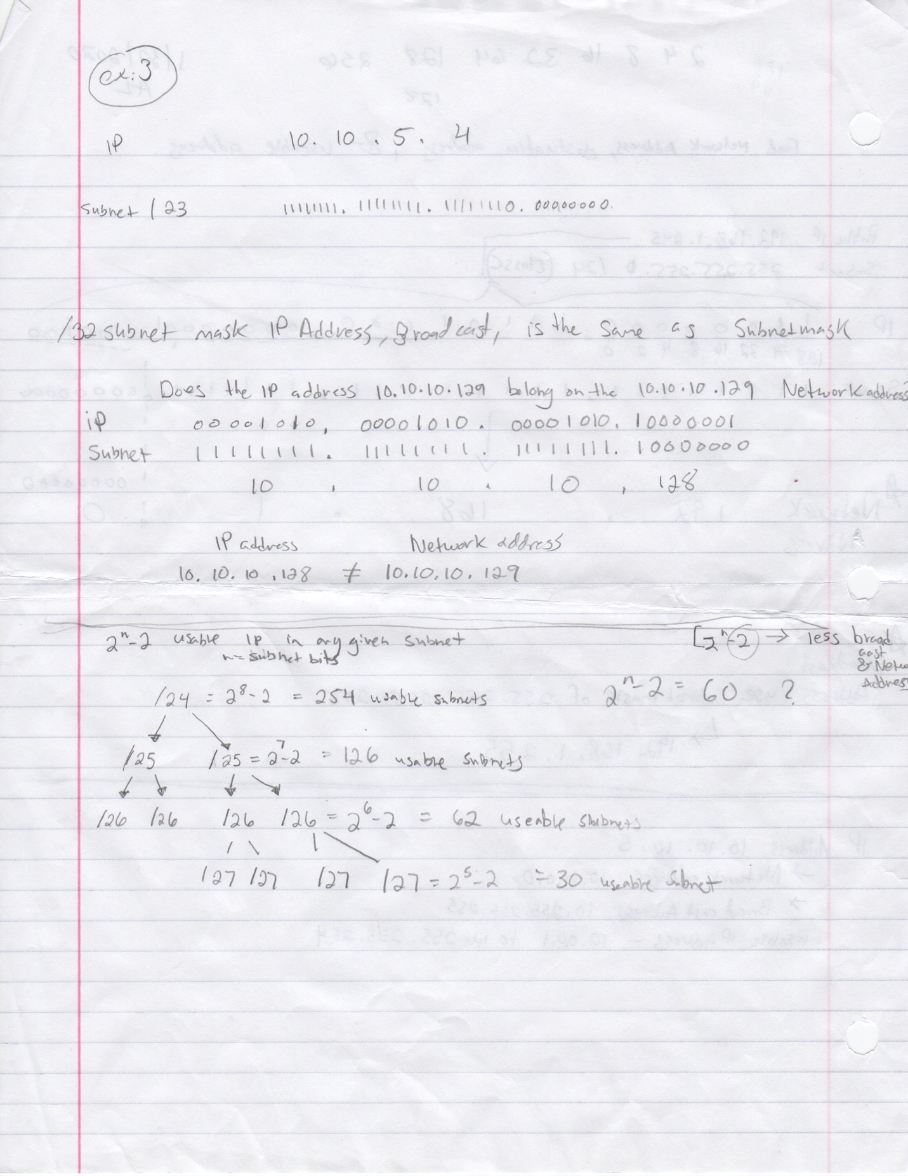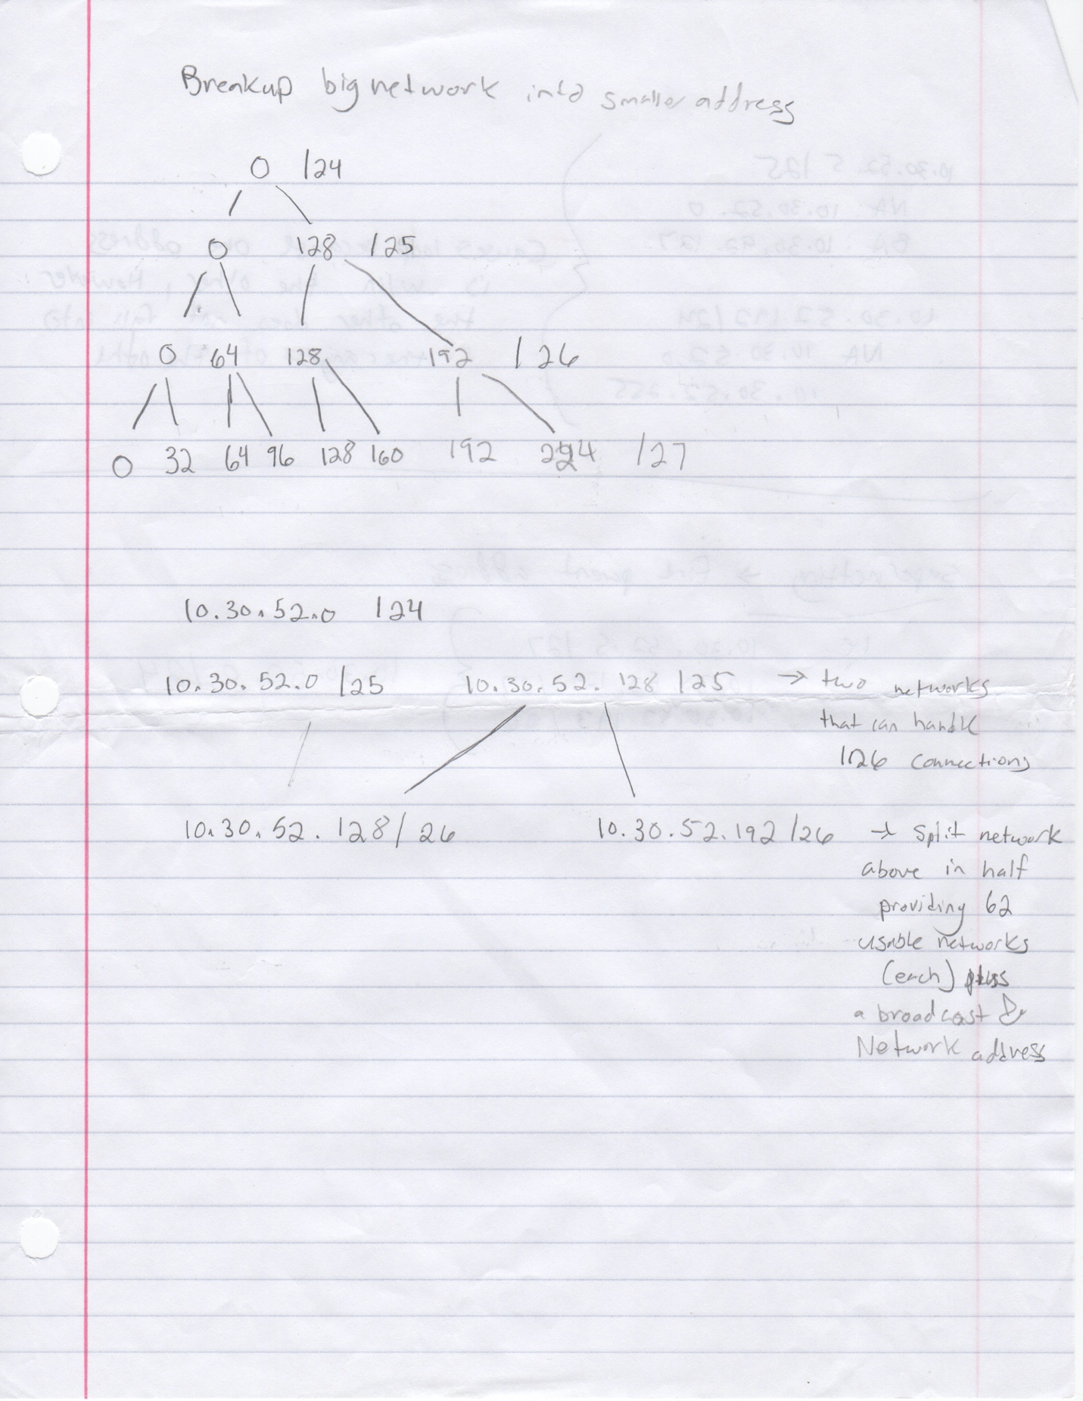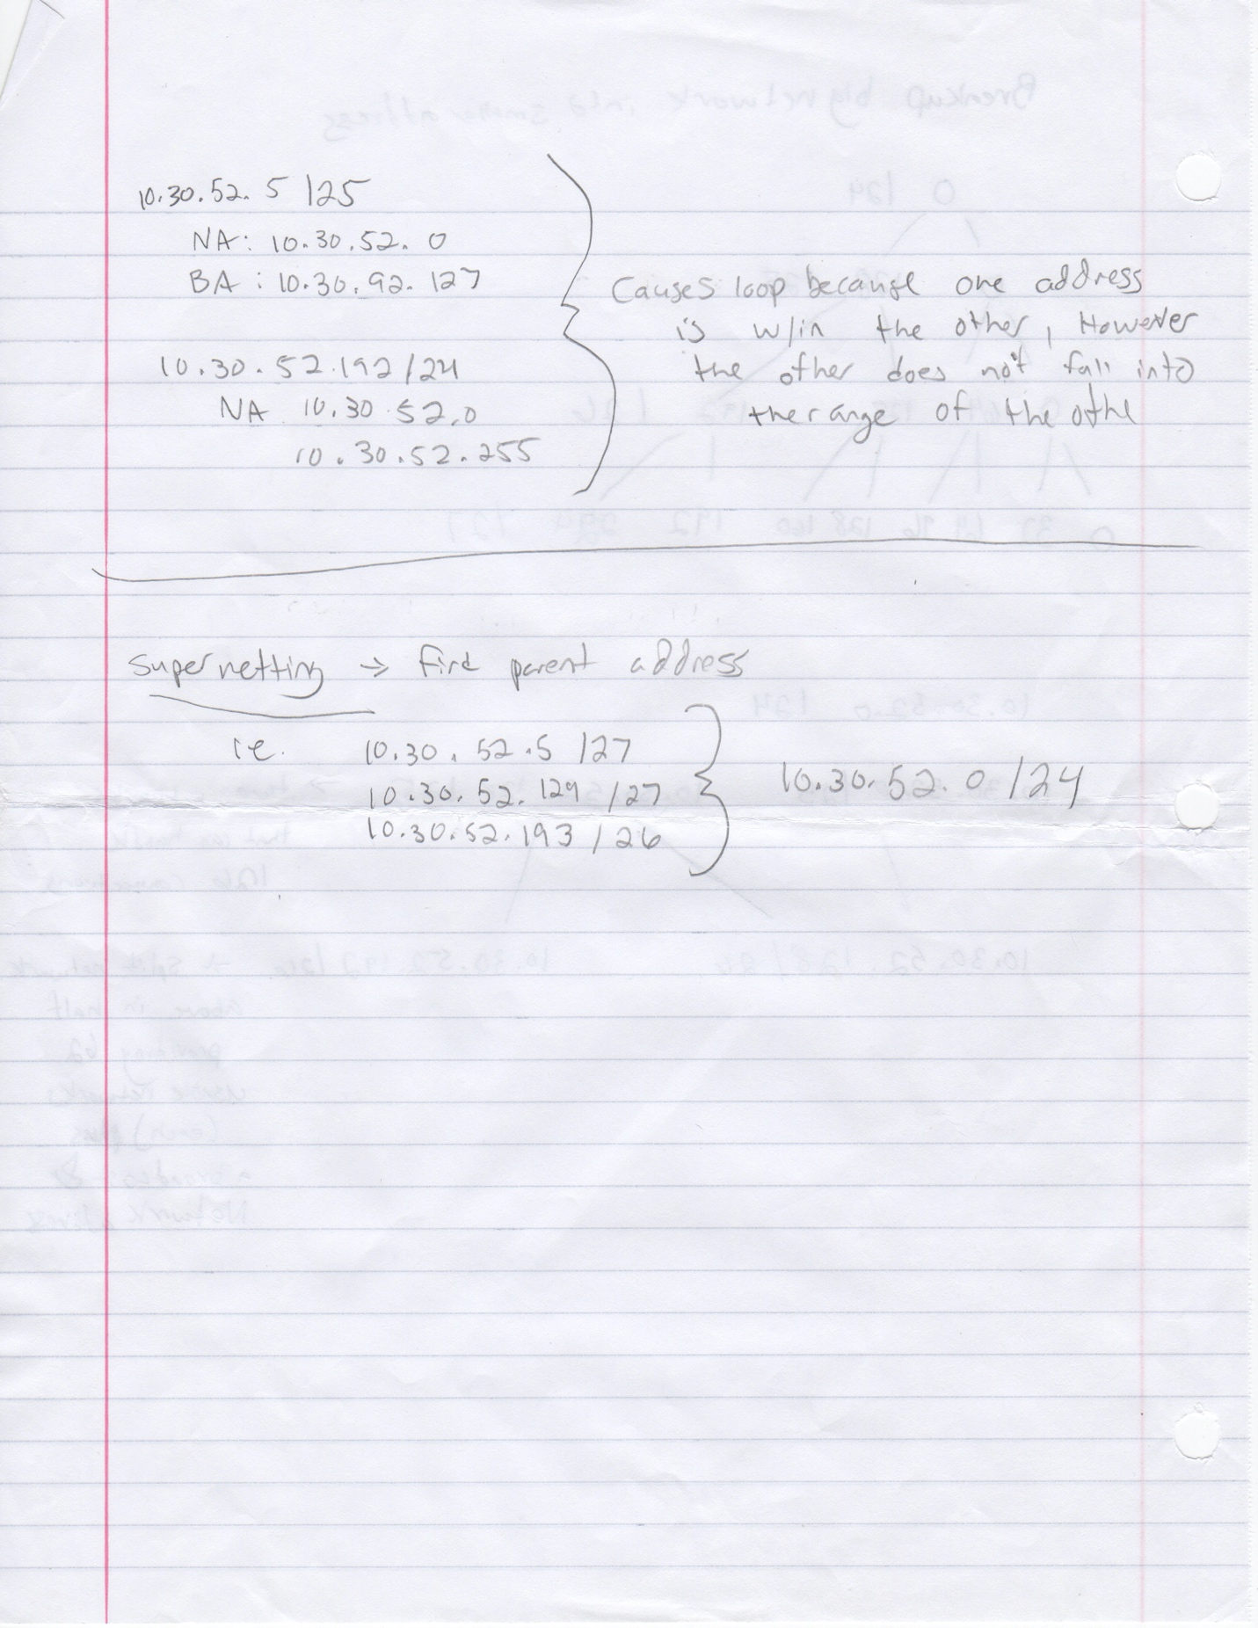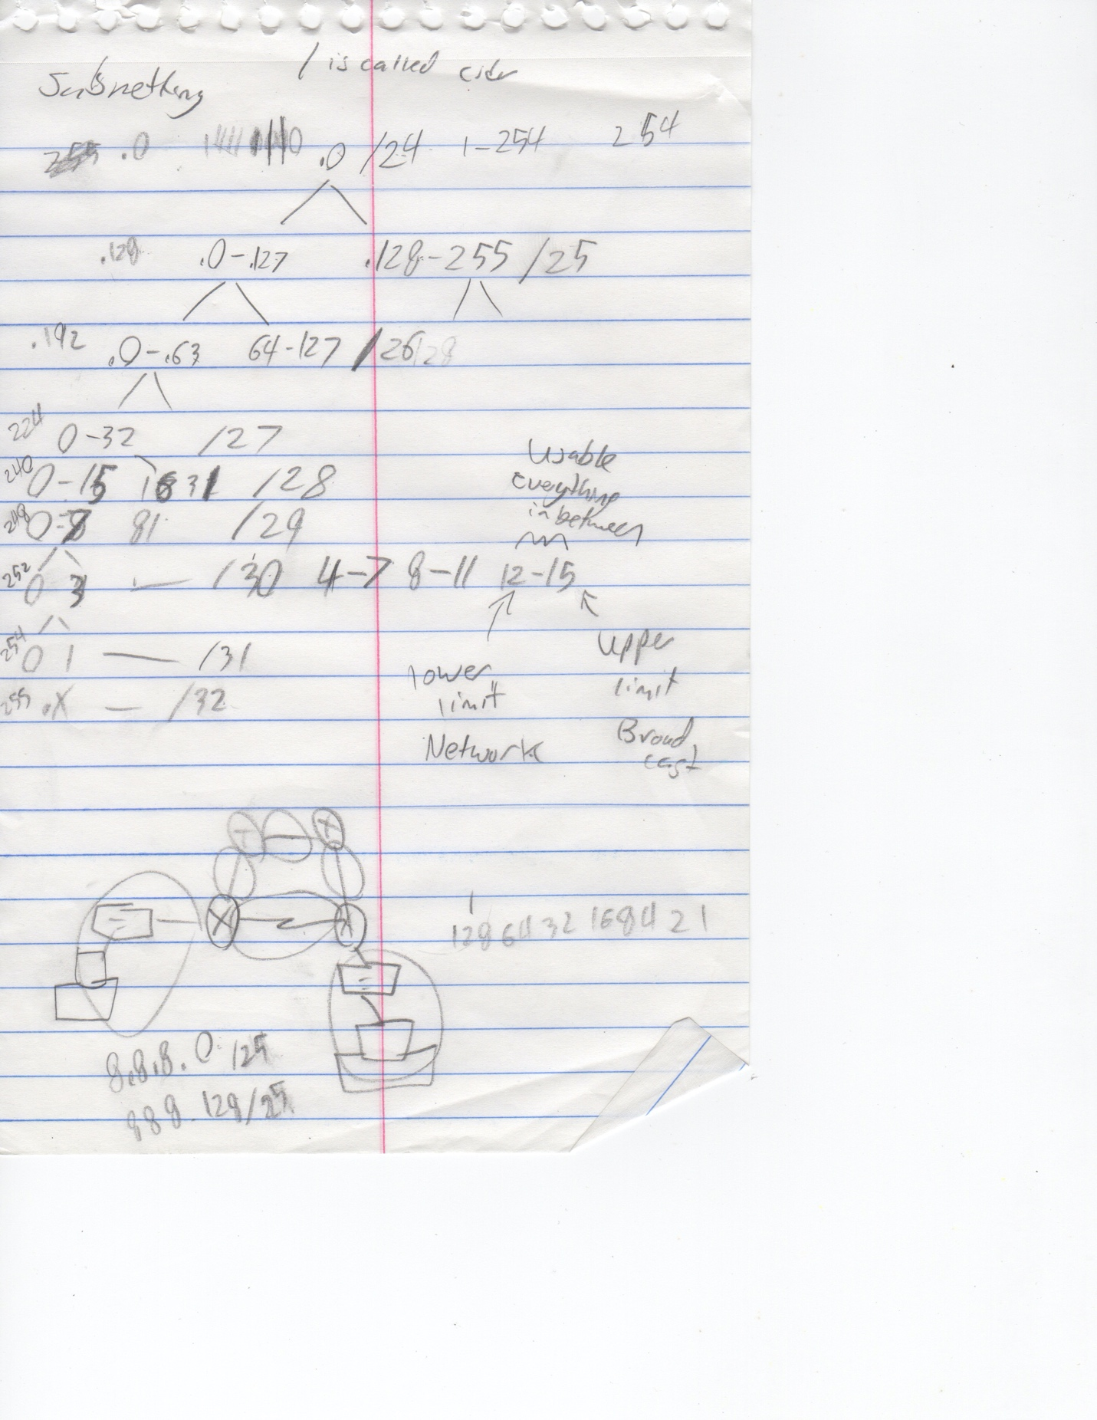

Internetworking Class 2 - January 30th 2020

IP

Public vs private IP

Subnet masks

Class A: 0-128^-1 255.0.0.0

Class B: 128-192^-1 255.255.0.0

Class C: 192 – 224^-1 255.255.255.0

(there are class D and E use for research)

Private class IP address

10.0.0.0 – 10.255.255.255

172.16.0.0 – 172.31.255.255

192.168.0.0 – 168.255.255

Network address will always have an even address(except in /32 subnet masks)

Broad cast address is always odd!

*Class 3: VLAN* – February 6th 2020

VLAN provide security and separation of data.

Trunk line – will allow any packets to pass through regardless of packet specification.

VTP – variable trunking protocol: allows us to set up a master for the other devices.

Vlan Trunking Protocol (VTP) – Cisco proprietary tool that advertises each VLAN configured in one switch (with the vlan *number* command) so that all the other switches in the campus learn about that vlan.

Commands:

Switch(config)# vtp mode client 🡪 changes the switch to VTP client mode

Switch(config)# vtp mode server 🡪 by default, all catalyst switches are in server mode

Switch(config)# vtp domain

Switch(config)# vtp password

Spanning tree - that prevents loops (complicated formula to determine the best device to route traffic) every 30 to 45 seconds the STP will automatically send an STP frame to verify the best route and determine loops – and send information accordingly.

**Vlan Setup on Cisco Switches:**

**Name vlan**

En > config T > Vlan # > name VlanName

**Verify vlan**

Show vlan brief

**Set access mode:**

En > config t> interface Port# > switchport mode access/trunk

**Set access mode for Vlan:**

En > config t> interface Port# > switchport access vlan#

Class 4: (Routing) 2/13/2020

Cisco Switch ports are normal open to communicate with any device on the device. Routers are the exact opposite. Every interface needs it’s own ip address.

Setting static IP address in CLI on cisco routers: you must be in global config type in:

IP Route *some ip address*

*Class 4 Routing Protocols OSPF - 2/20/20.*

*Open Shortest Path First*

*Inverse binary relationship*

*Routers only care about what is connect to it.*

“Default-information originate”

**default-information originate** command will send ospf information to other routers connected to device. Used on the edge router connected to the ISP. Only used with OSPF

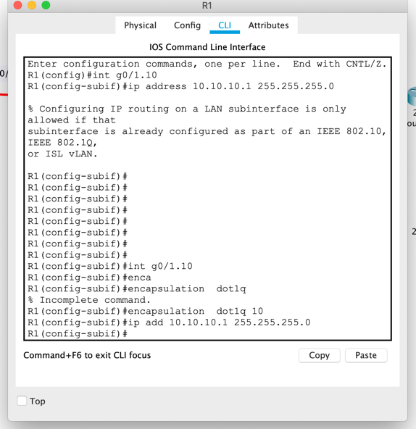

*Sub interface commands*

***Class 5 ACLS*** *- February 27th 2020*

*ACL – Access control lists*

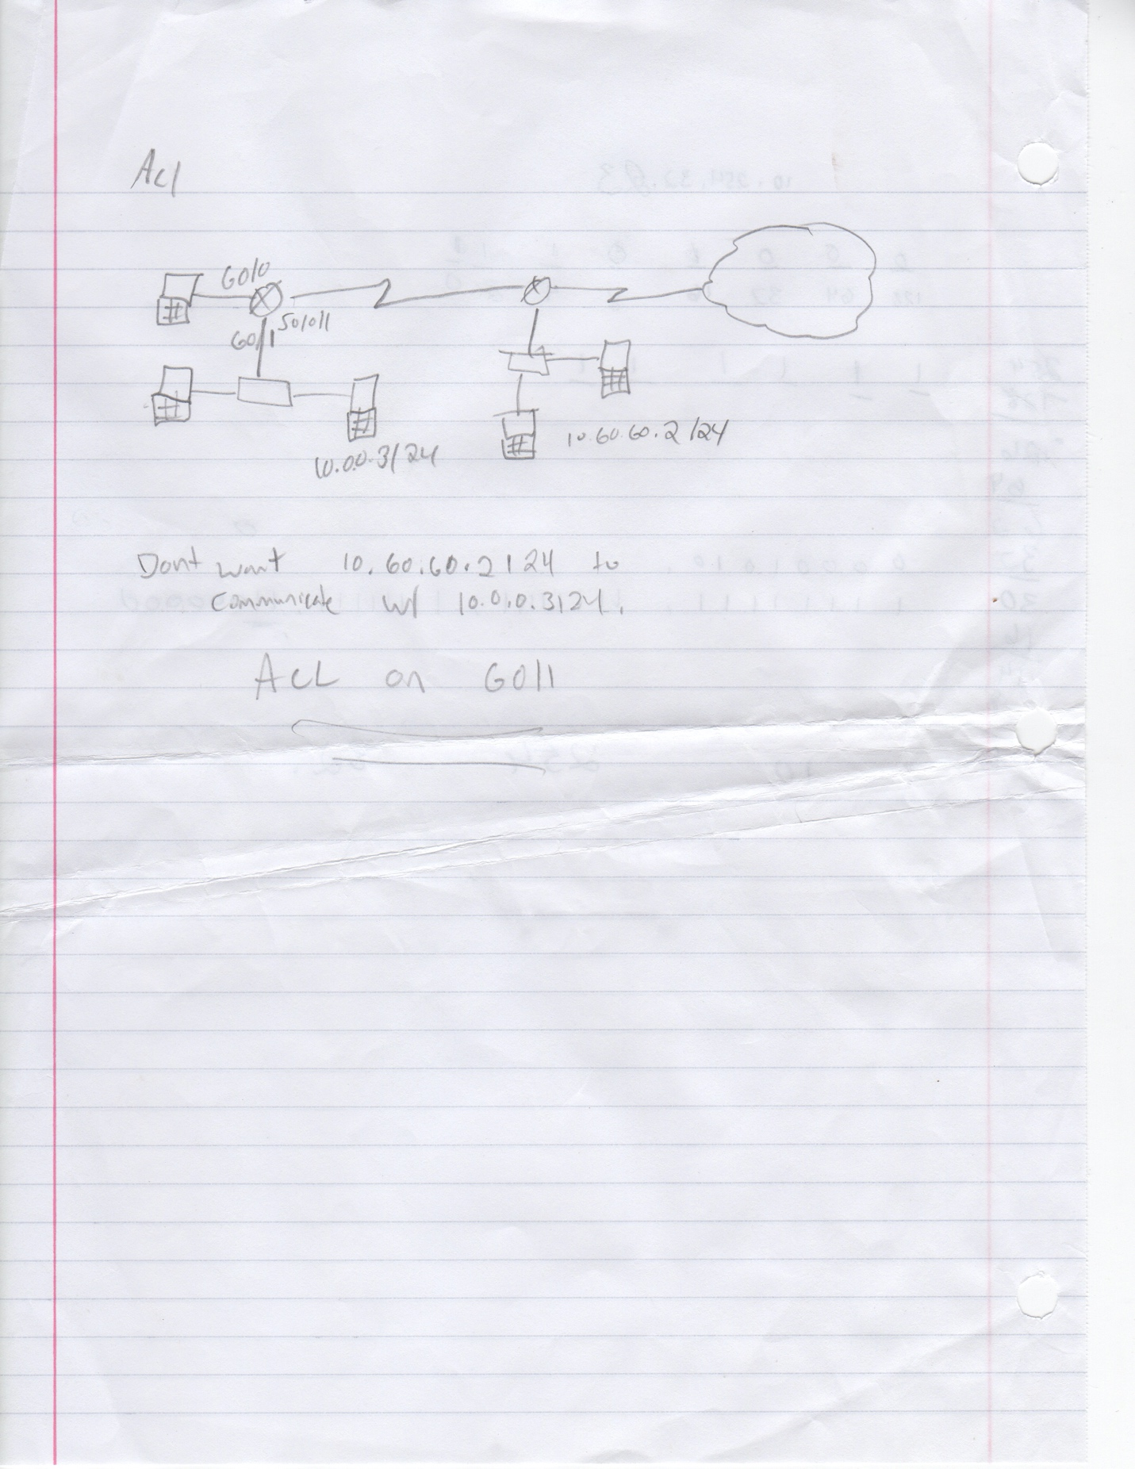

*Out vs IN*

*Standard = 1-99. Checks for IP Address.*

*Extended = 100 -199 check for ports (FTP, Web, etc..)*

*Permit vs deny*

*Rule 1, rule 2, rule 3…. Rule X*

*Where x is the last rule on the list is reserved for deny all option. Deny all is set by default. & rule X-1 is an option for permit any, which is explicitly stated. Each rule is basically an “if-statement.”*

standard is closest to the destination

extended is closest to the source

***To set an access list to an existing port***

commands:

router(config)# access-list <access list number> deny any

router(config-int)# interface <interface in which to apply rule>

router(config-int)# ***Ip access-group 11 in/ out.***

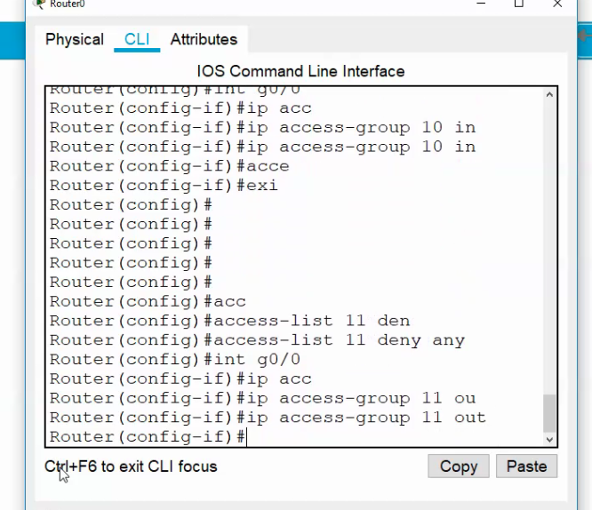

NAT AND PAT  
Network address translation – uses ip address

Port address translation – uses port number between 1 -~65000 the port refers to the port with in the packet

* Need access list for static nat

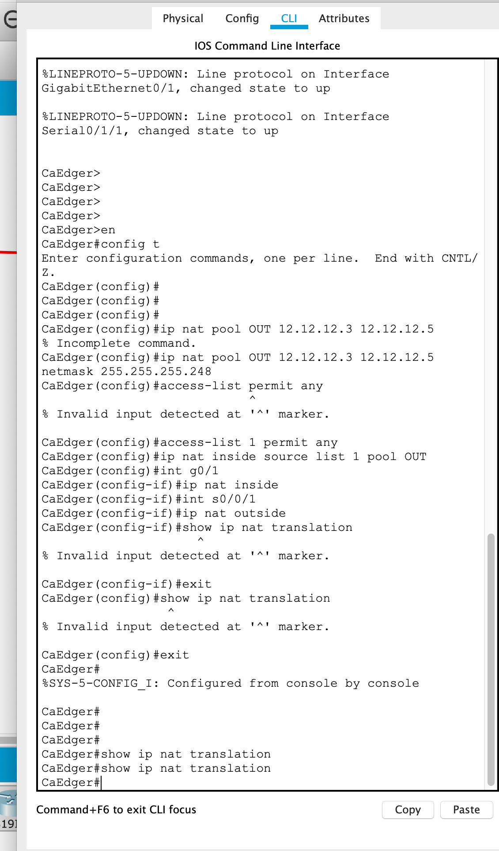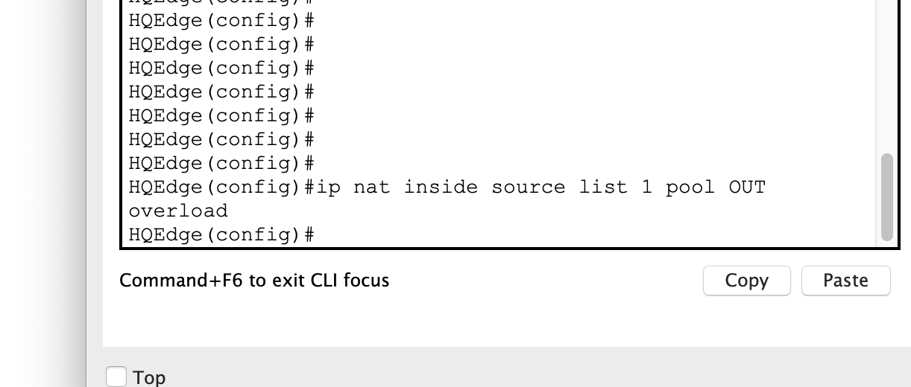

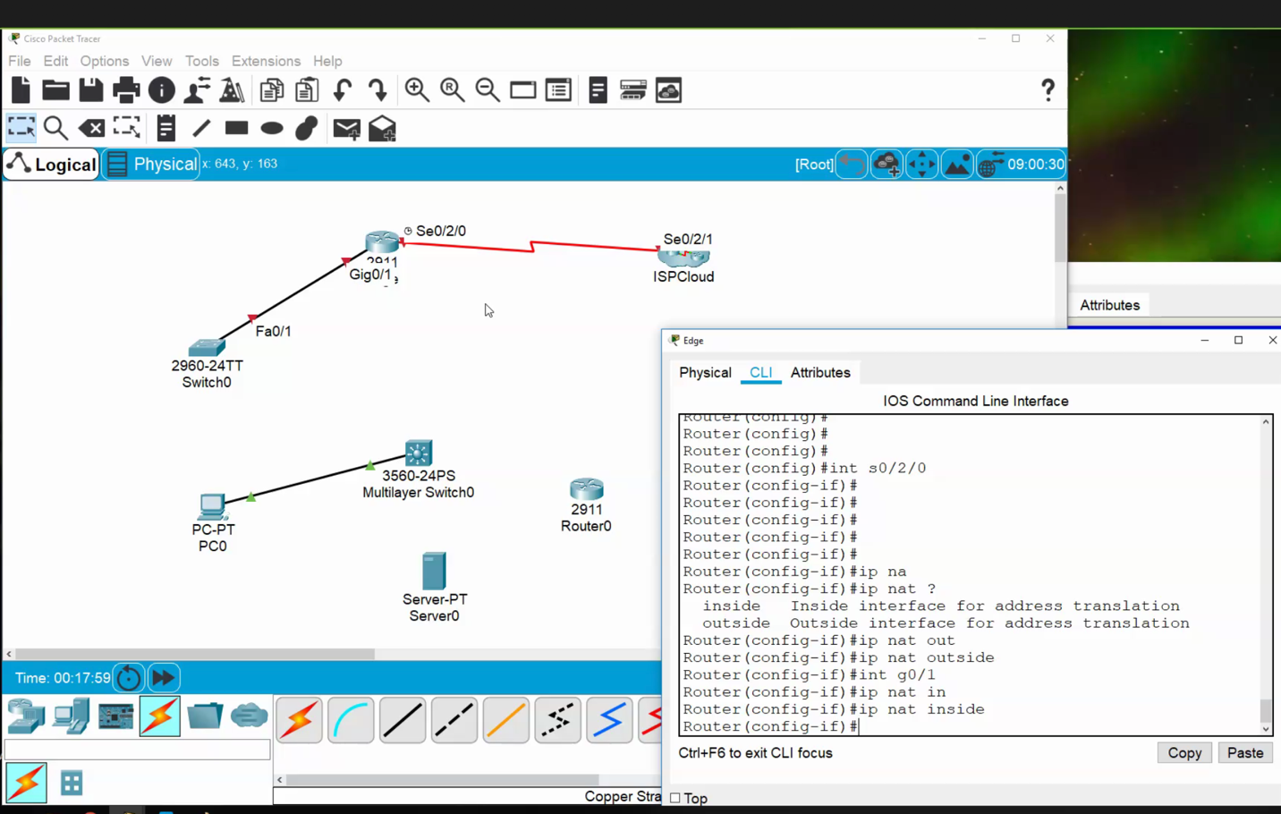

***Class 6*** *- March 5th 2020*

***Class 7***  *- March 12th 2020*

*Spring Break Extended One week*

***Class 8***  *Recap And Multi Protocol Switches- April 2nd 2020*

*ONLINE LEARNING DUE TO CORONA VIRUS*

Class 9 - April 9, 2020

1. Using switches(2960) multiple crossover cables in between switches

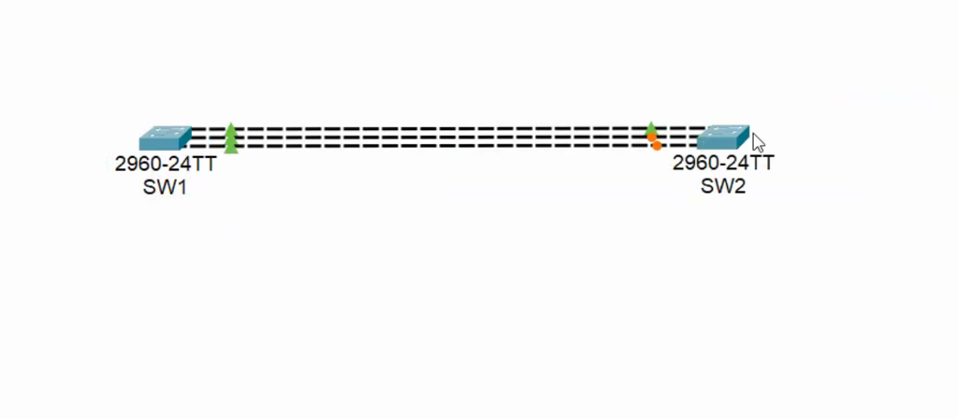

Channel grouping – logical grouping of ports that decides which port to use…

Must been done on both switches:

Command:

Range int fa0/1-6

Switch port mode trunk

channel-group 1 mode on

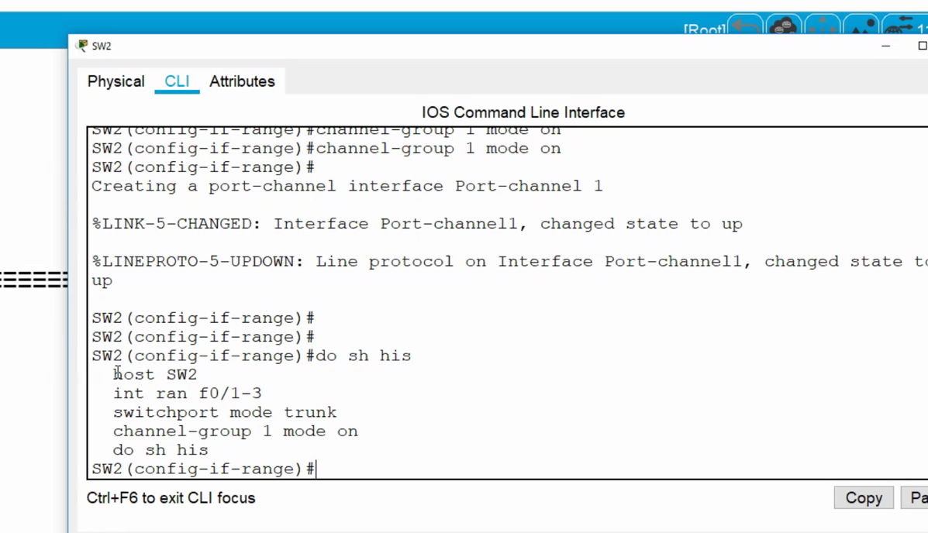

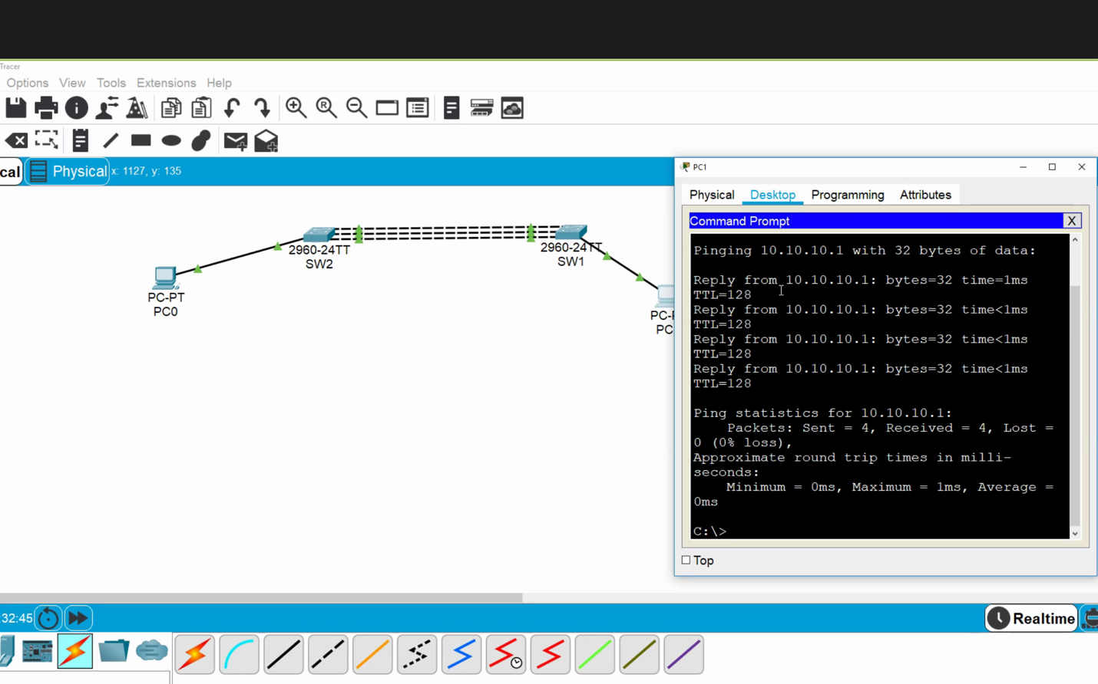

If a connection is cut the other lines will pick up the volume, however the bandwidth will be reduced.

Also, not shown, you can create multiple channel groups switched connections to other switches (like three swithes in a trianle with 3 connections inbetween each)

1. Setup authentication between devices

Basics:

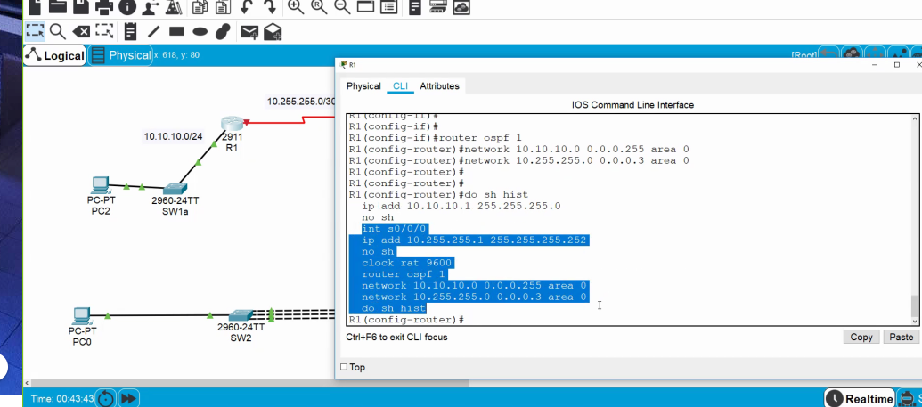

User name has to be the name of the router than we are connecting to.

Command:

Username *‘Router2’* password *‘cisco’*

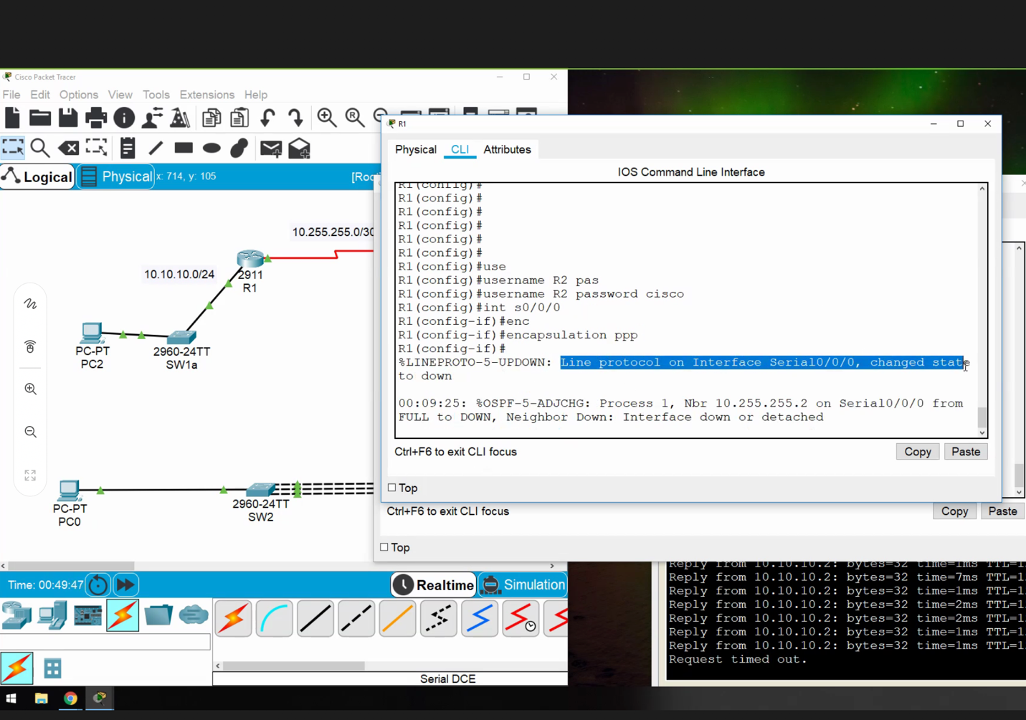

After we create encapsulation we have to specify the type of PPP (PAP is antiquated).

Command for hand shake: **ppp authentifcation chap**

Must enter user name of router conneted to, the password must be the same!!!

Advance topic, you can use PPP to encrypt traffic over another network.

Class 10 - April 16, 2020

Get rid of errors pop ups

Line console 0

Logging Synchronous

(or)

No Logging console

*Redistribute* command – redistributing routes

Send other routing protocols through a router

New routing protocol: eigrp

Command: (from configure ) ‘router eigrp 1’

Use the redistribute command to send the static route to other devices on the network

EIGRP has a clear speed advantage when compared to OSPF. OSPF runs every 30 seconds. EIGRP is a Cisco proprietary protocol that is more instantance.